Rotary Club of Kathmandu Mid-Town
Breakfast Chatter



27 October 2006 The Weekly Bulletin of Rotary Club of Kathmandu Mid-Town Bc # 17 of 2006-07

District : 3290 Web: www.rotarymidtown.org.np Club Id : 26776

OCTOBER IS VOCATIONAL SERVICE MONTH
Through our many youth programs, we can take a lead in vocational service. Young people are our future, and vocational service is the key to a better foundation that will benefit all of us.
Vocational Service can help others gain a better life, a better standard, a better world.

Talk program on Significance of Vocational Training in Rotary
at the Club meeting on Friday, 20 Oct 2006.
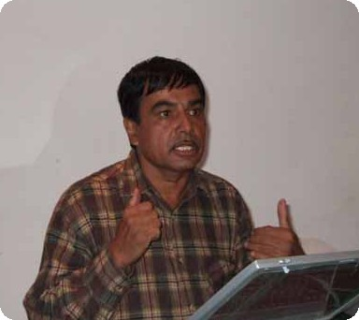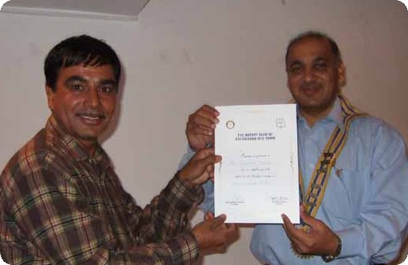
(a) Guest Speaker Rtn Surendra Dhakal addressing at the Club meeting (b) President CK Golchha
presenting a Letter of Appreciation to the guest speaker.

Weekly Meetings and Programs :
Date | Program/Speaker | Program/Topics of Presentation
27 October 2006 | Dinner meeting | DG's official visit to the Club
3 Nov 2006 | Dr Isabella CB Khadka | Past Reminiscences and Present Musings
10 Nov 2006

Friday, 27 October :
Mid-Towners ! Please be informed that there would be no regular meeting on October 27 Friday morning. You don't need hurrying up early morning that day to go to Annapurna Hotel as we have been hitherto used to. You can have extra one hour sleeping if you would like to.
Instead we have Dinner meeting that day evening, that is, on 27 October.
The venue is Annapurna Hotel, Durbar-marg; Time: 18:00 hrs.
Registration: Members Rs 400; with spouse or other family member Rs 600.
DG Debasish Mitra will be in the meeting reviewing the Club's plan, program and activities.
All Directors and project coordinators will be presenting reports of the respective avenues and projects to the DG.

Extracts of Article :
(Some extracts from the article titled Putting Service Above Self by Prof E Adedolapo Lufadeju, PDG, currently RFPD Area Coordinator – Africa, are provided below for benefits of the readers; the article is published in RFPD magazine Fragile Earth – September 2006).
Those who have been in Rotary for many years might have heard this familiar story. Ten Rotarians are appointed to a committee to help solve a problem. But when the chips are down, only two of them can be found! The rest of them? One is too busy, another is fulfilling his classification, yet another had to travel on emergency, and so on and so forth. What happens to the assignment? The poor ones left there begin to run from pillar to post, trying to do the work of ten people. So should we ask ourselves, what motivates a Rotarian to serve?
How many of us have found ourselves in a position to help others and have declined to do so? How many of us, in spite of our willingness to help others, do not have the wherewithal to do so? How many of us even have not cared what happens to our fellow men? Must we reach a state of personal satisfaction and well-being ourselves, before we can begin to think of others? At what time of our lives do we consider ourselves satisfied enough, so that we can take on the problems of the less privileged?
How do we begin to learn to give from what we have, to improve the lives of others? One does not have to be the richest man in the World to be able to share. Isn’t part of the irony of life that those who have little tend to share what they have with others?
Serving others voluntarily carries an innate conviction of concern for the well being of humanity. This is the ideal of Rotary. We search to identify the needs of others, then we help them satisfy those needs, and then we enjoy the sweet sensation and joy in the realization that we have made somebody happy.
The Rotary Motto: ‘Service above Self’ can be seen in two ways. One, it means that we ourselves are not in anyway become the beneficiaries of our good deeds. It may also mean that we pay little attention to our own needs and attend to the needs of others.
‘Service above Self’ is best exemplified through charitable and educational programs, based on unselfish service to deserving persons who are not Rotarians or their relatives.”
There may be many reasons why you joined Rotary and many of these reasons are indeed beneficial. Among all benefits, the most important is the opportunity to serve. Rotary is a service organization. Its client is mankind; its product is service.
courtsey: PP Hartmut Bauder

News/Opinions :
Bal Kshetra Nepal, a local NGO and the Stichting Veldwerk, a Dutch INGO, launched a project titled Hamro Gaun with the objective of turning the historic spot of Sankhu into a model village. The project aims to build a learning centre for school dropouts, a daycare centre for local children, a vocational training centre for disadvantaged women, an orphanage for orphans and involve in other activities. It is a small but self-reliant and eco-friendly project dedicated mainly to the destitute children and women, says Rene Veldt, program director of the project.
The out-of-school children from Sankhu and surrounding areas will be provided non-formal education at the learning centre. The orphanage home is expected to provide shelter to over 50 orphans in the beginning. A micro-hydropower plant will be installed in a nearby river to generate power needed for the project. Biogas plants will supply energy needed for cooking and other purposes. A sun kitchen will also be installed. The project will use local resources for all needs. All buildings under the project will be built in traditional Newari style.
Could we, RC Kathmandu Mid-Town, take a lead role in supporting this vocational training centre by providing resource persons or materials needed in coordination with the project, Hamro Gaun ?
Please send your opinion to the editor, or to the Club's Vocational Service Director.

On Lighter Side : Click at the figure ⇩


When I ask you to Lead the Way, I ask you to see the needs of your communities and Lead the Way to addressing them. I ask you to look at the broader international picture and to Lead the Way to a safer, healthier, and fairer world, through our own efforts and through our example to others.
RI President William B. Boyd

27 October 2006 The Weekly Bulletin of Rotary Club of Kathmandu Mid-Town Bc # 17 of 2006-07

Editor: RR Shrestha, Club Service Director email: rryes@wlink.com.np

